- Landing page:
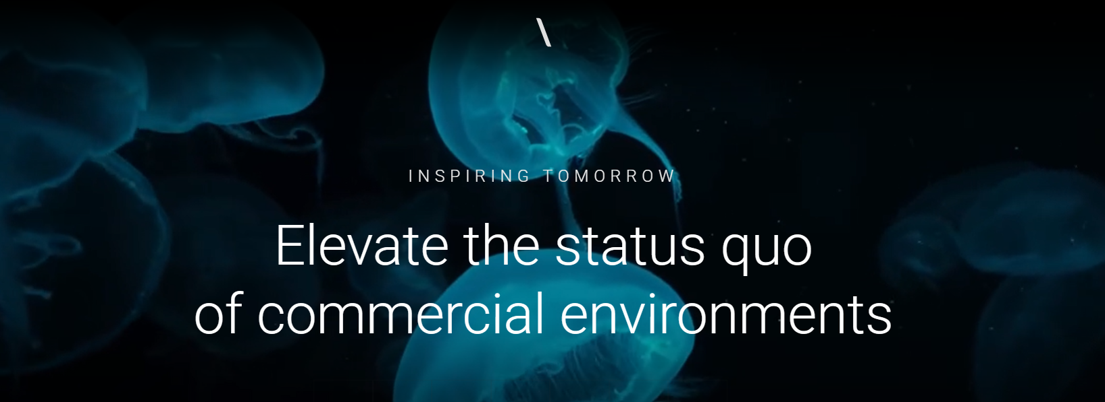
Add the logo on the top. When clicked this logo will perform the same by listing the below pages:
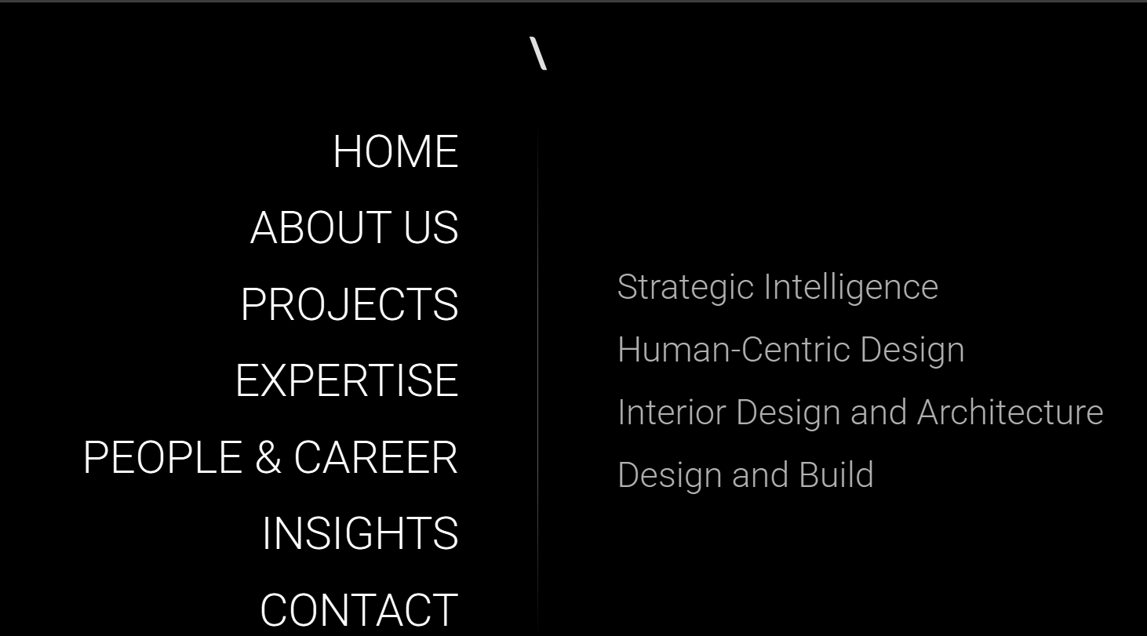

INSPIRING TOMORROW replace it with DESIGN BEYOND

Elevate the status…. replace it with “Between Earth and Sky, Everything Is Orange”

- About us – Who we are

Who we are :
We design spaces shaped by people, place and everyday life.

Click dive in and the following ;
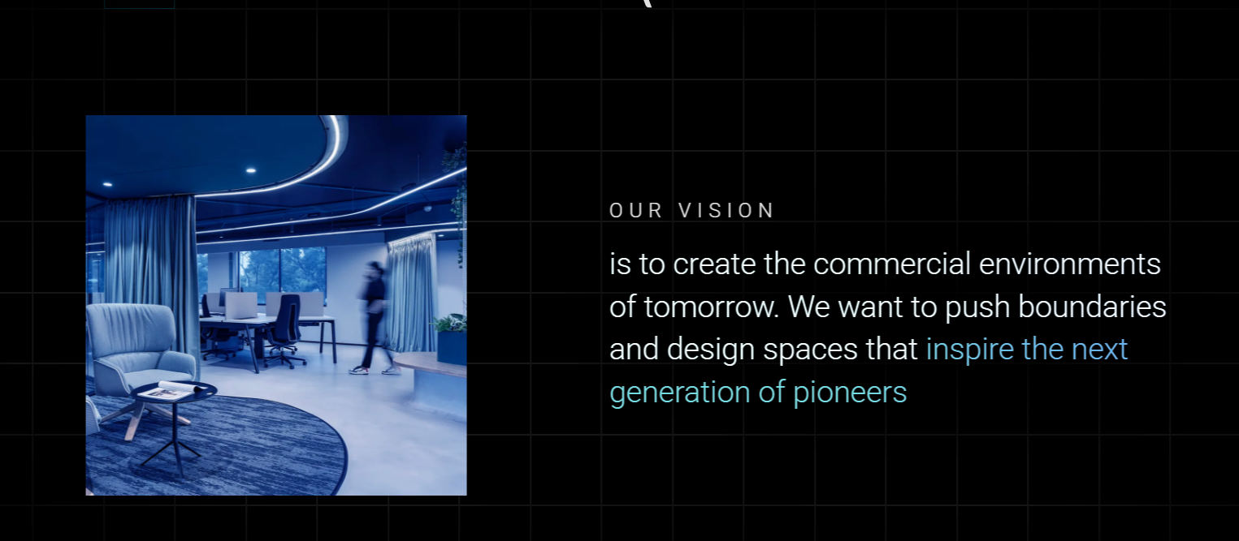
Replace our vision with Who:
Urth Studio is an architecture and interior design practice shaped by people, place and the rhythms of everyday life.
The studio grew from a body of independent work, shared experience and a clear ambition to establish a practice with its own identity, values and design perspective.

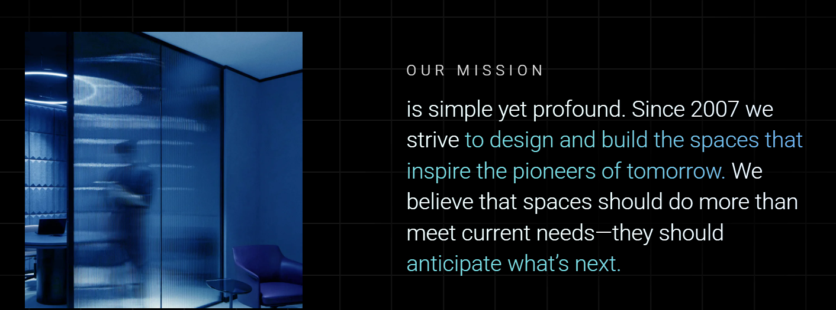

Replace our vision with Who :
Urth is an architecture and interior design practice shaped by people, place and the rhythms of everyday life.
The studio grew from a body of independent work, shared experience and a clear ambition to establish a practice with its own identity, values and design perspective.
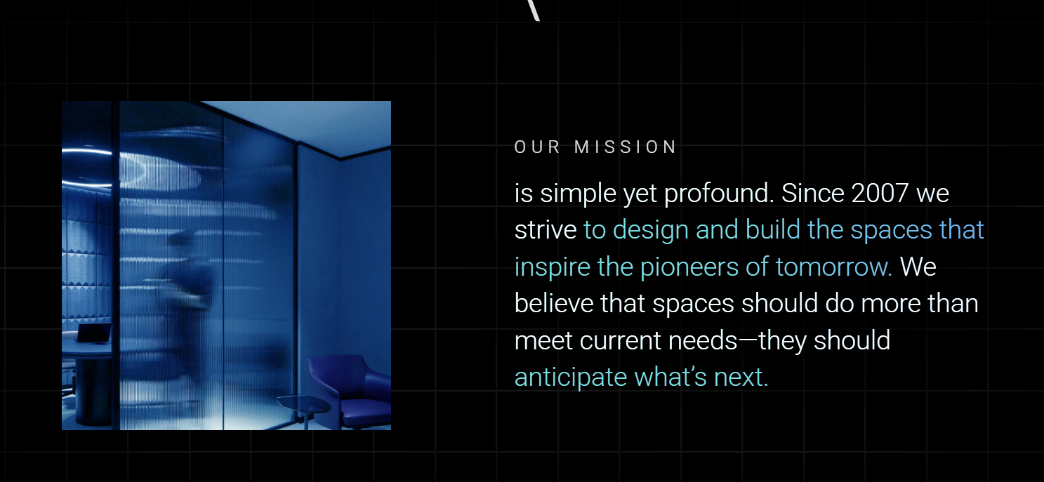
Replace our mission with Why :
Urth was founded from the belief that thoughtful design requires clarity, purpose and intention.
What began as individual projects evolved into a broader vision: to create architecture and interiors that are considered, relevant and responsive to the people and places they serve.
Urth is our way of building something with intention—nothing forced, nothing without reason.
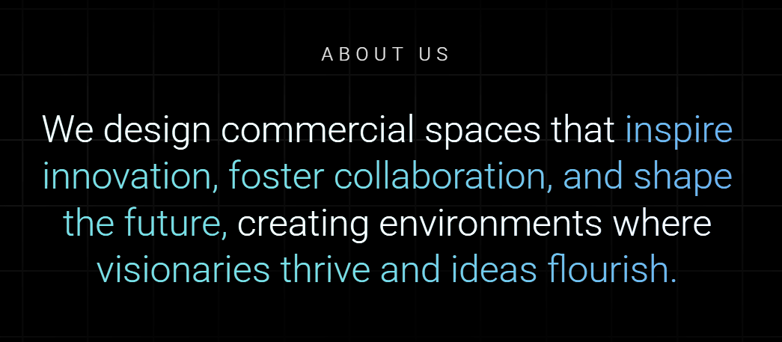
Replace About us with What

Urth draws from earth, place and intuition.
The ground from which we begin.
The context we respond to.
The instinct that tells us when something truly belongs.

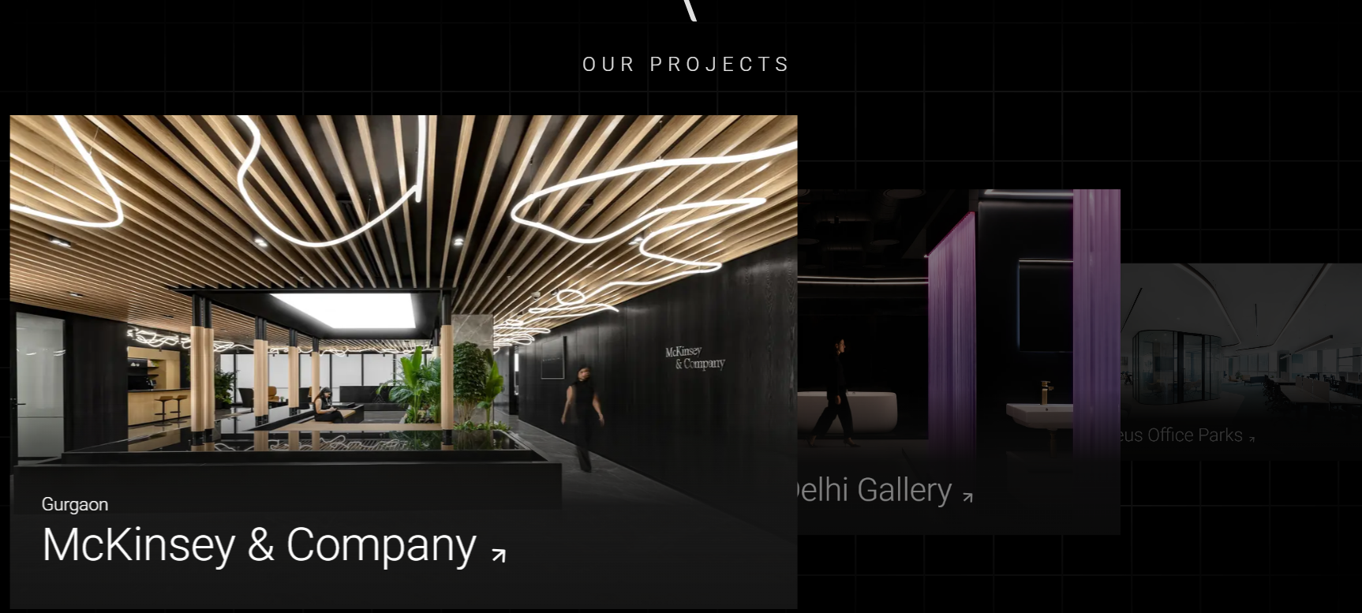
I will send this separately in a folder.

WE DON’T HAVE OUR CLIENT FOR NOW SO CANCEL IT

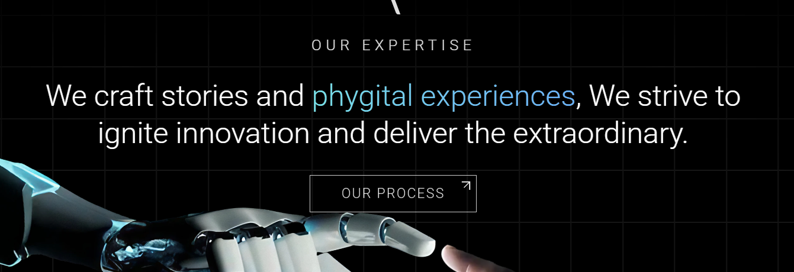

Replace our expertise with Let us get started with your journey
Reference of the flow of the journey can be like this: https://initiatearchitecture.com/pages/services

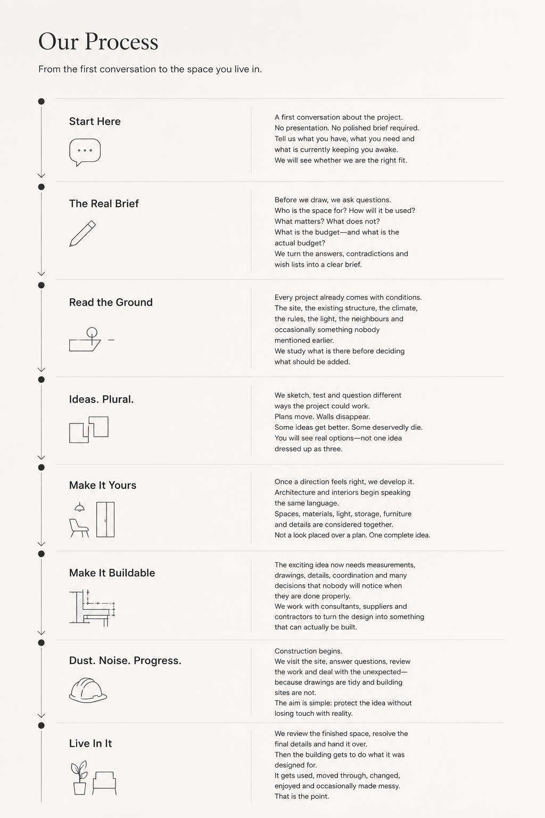
Let’s make something real.
You may have a plot, a half-formed idea, an existing space that does not work—or just a folder full of references that contradict one another.
That is enough to begin.
Where are you in the process?
0
Start Here
A first conversation about the project.
No presentation. No polished brief required. Tell us what you have, what you need and what is currently keeping you awake.
We will see whether we are the right fit.
Say hello

1
The Real Brief
Before we draw, we ask questions.
Who is the space for? How will it be used? What matters? What does not? What is the budget—and what is the actual budget?
We turn the answers, contradictions and wish lists into a clear brief.

2
Read the Ground
Every project already comes with conditions.
The site, the existing structure, the climate, the rules, the light, the neighbours and occasionally something nobody mentioned earlier.
We study what is there before deciding what should be added.

3
Ideas. Plural.
We sketch, test and question different ways the project could work.
Plans move. Walls disappear. Some ideas get better. Some deservedly die.
You will see real options—not one idea dressed up as three.

4
Make It Yours
Once a direction feels right, we develop it.
Architecture and interiors begin speaking the same language. Spaces, materials, light, storage, furniture and details are considered together.
Not a look placed over a plan. One complete idea.

5
Make It Buildable
The exciting idea now needs measurements, drawings, details, coordination and many decisions that nobody will notice when they are done properly.
We work with consultants, suppliers and contractors to turn the design into something that can actually be built.

6
Dust. Noise. Progress.
Construction begins.
We visit the site, answer questions, review the work and deal with the unexpected—because drawings are tidy and building sites are not.
The aim is simple: protect the idea without losing touch with reality.

7
Live In It
We review the finished space, resolve the final details and hand it over.
Then the building gets to do what it was designed for.
It gets used, moved through, changed, enjoyed and occasionally made messy.
That is the point.

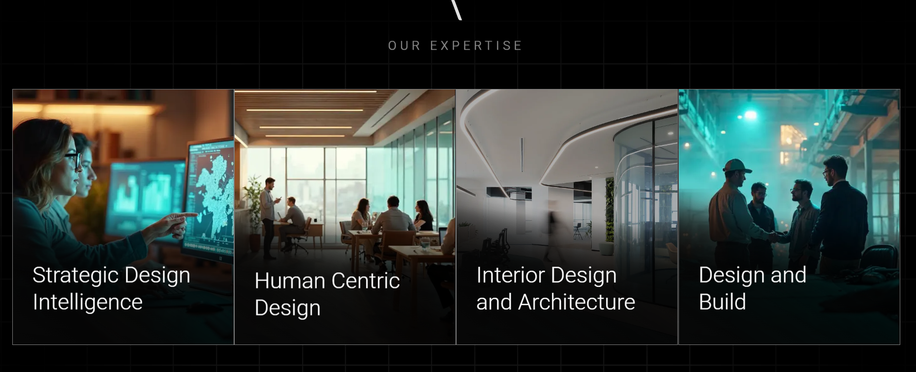
KEEP OUR EXPERTISE
Replace strategic design intelligence with Architecture
We design architecture that responds to its site, climate, context and the people who will use it. From planning and spatial flow to form, light and material, every element is shaped as part of one clear and purposeful idea.
Human-Centric Design
We design around the way people live, work and move through space. Every decision is guided by comfort, experience, function and a genuine understanding of human needs.
Interior Design
We approach architecture and interiors as one connected idea. Space, structure, material, light and detail are developed together to create a cohesive and considered environment.
Design Management
We guide the project from concept to completion, coordinating specialist consultants. Our role is to align technical inputs, timelines and design decisions while protecting the overall vision of the project.

I have attached separate image for these 4 sub headings

Contact
